**EXPERIMENT 5**

DDL COMMANDS (COLLEGE SCHEMA)

Aim:

* Create a schema called College.
* Create tables for students (attributes: student id, name, gender, subject, marks and grade), faculty (attributes: faculty id, name, course and pass percentage), department (attributes: department id, name, section, strength and pass percentage) and activity (attributes: activity id, name, strength and category)
* Add and modify:
  + Address in students table, change datatype size of student name and make student id primary key
  + Add faculty total mentor details, make faculty id as primary key
  + Add number of students in wise in department table and make department id as primary key

Add faculty name to activity table, change the datatype size of activity

name and make activity id as primary key

1. Create a schema called College.



1. Create tables for:

a. students (attributes: student id, name, gender, subject, marks, grade)

b. faculty (attributes: faculty id, name, course, pass percentage)

c. department (attributes: department id, name, section, strength, pass percentage)

d. activity (attributes: activity id, name, strength, category)

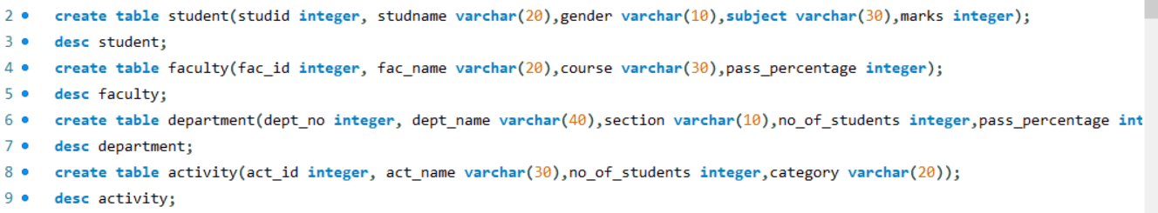

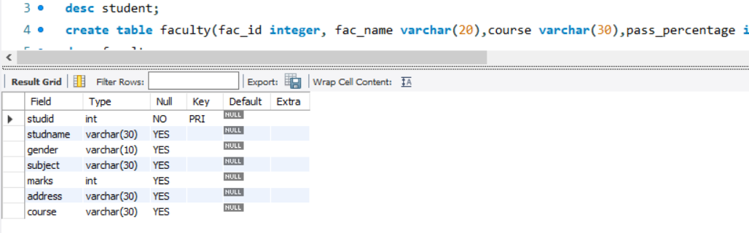

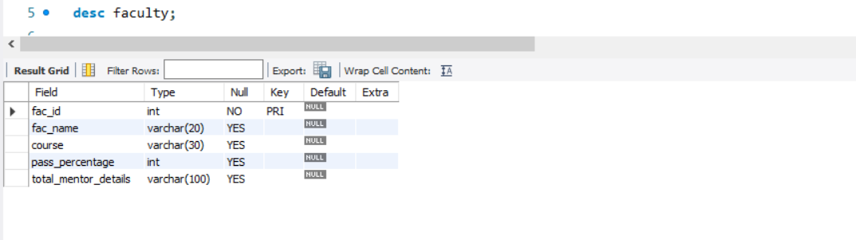

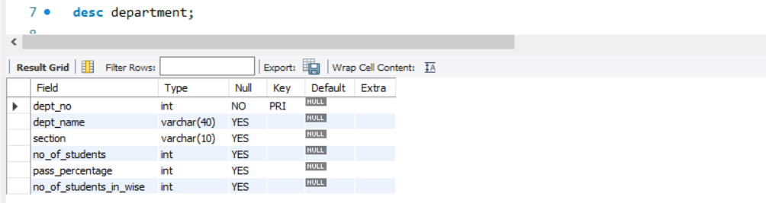

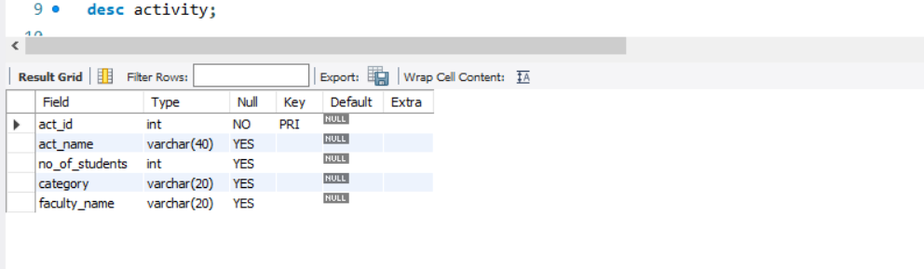

1. Add and modify:
   1. Address in students table, change datatype size of student name and make student id primary key
   2. Add faculty total mentor details, make faculty id as primary key
   3. Add number of students in wise in department table and make department id as primary key
2. Add faculty name to activity table, change the datatype size of activity name and make activity id as primary key

